

_____________________________________________________________________

**Assignment No 3**

**BSE – 8B**

**Course Title: Formal Methods**

**Submitted to: Mr. Riaz Ahmad**

**Session: SPRING-25**

**Course Code: CSE356**

**Submitted By**

|  |  |
| --- | --- |
| **Student Name** | **Registration No** |
| Abdullah Abid | FA21-BSE-071 |
| M.Umair Khan | FA21-BSE-070 |
| Zainab Bibi | FA21-BSE-059 |

**Assignment no 3**

Assignment Statement

**Step-by-Step Installation Guide**

**1. Launch the Installer**

* Double-click the downloaded EiffelStudio 25.02 (x64) Standard installer (.exe file).
* Click Next to proceed.

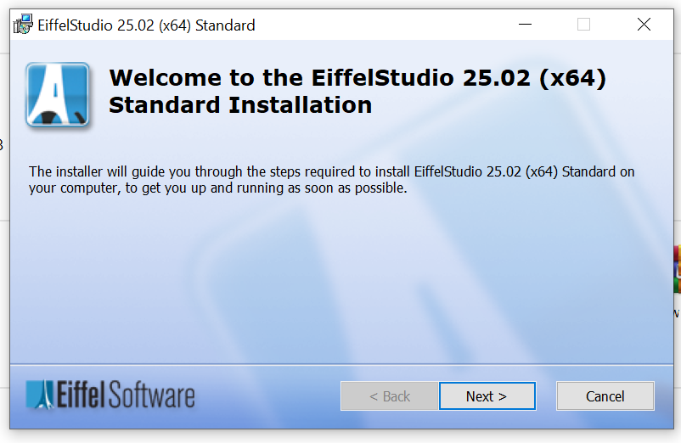

**2. Accept the License Agreement**

* Read the End-User License Agreement **(EULA).**
* Click **Agree** to continue.

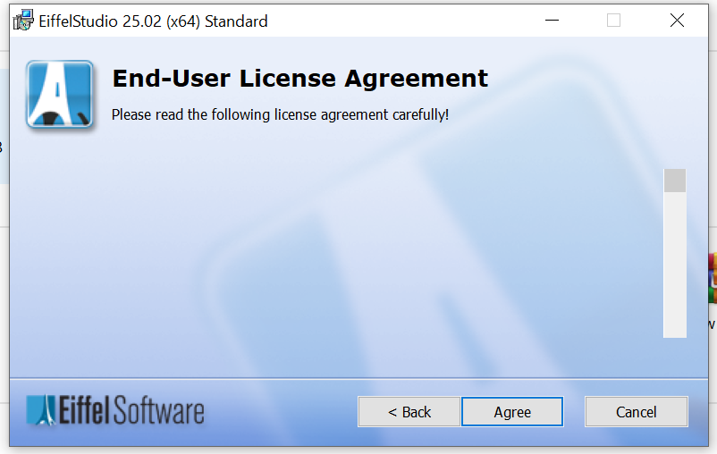

**3. Choose Installation Location**

* **Default Location:**

C:\Program Files\Eiffel Software\EiffelStudio 25.02 Standard

* **Custom Location:**

Click Browse to select a different folder (e.g., C:\Eiffel).

Avoid spaces/special characters in the path.

* Click **Next.**

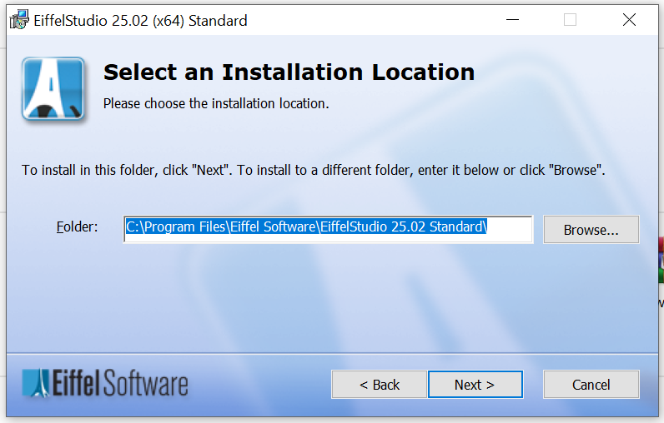

**4. Select Default Language**

* Choose your preferred language (e.g., **English (United States)**)**.**
* Click **Next.**

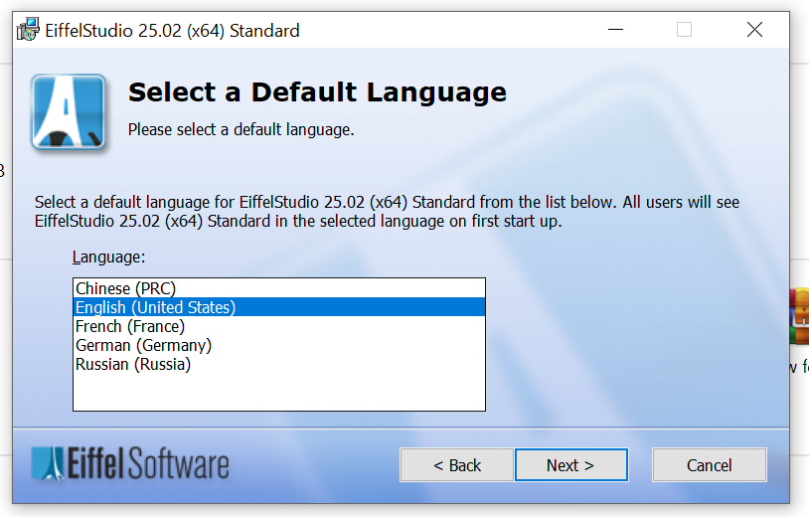

**5. Create Desktop Shortcut (Optional)**

* Check **☑ Create a shortcut on the desktop** (recommended).
* Click **Install** to begin installation.

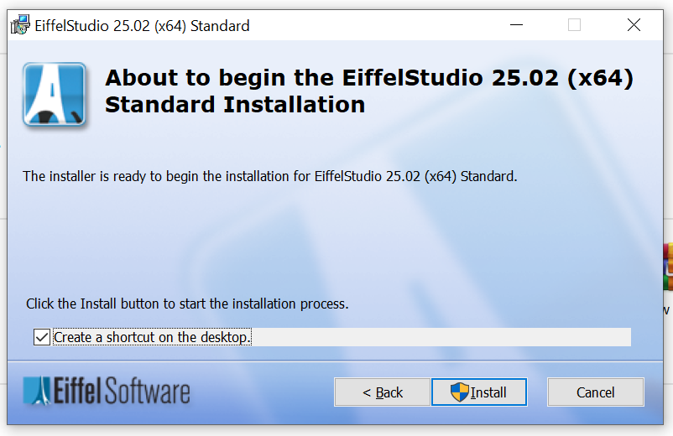

**6. Wait for Installation to Complete**

* The installer will extract and set up files.
* Progress will be shown in the status bar.

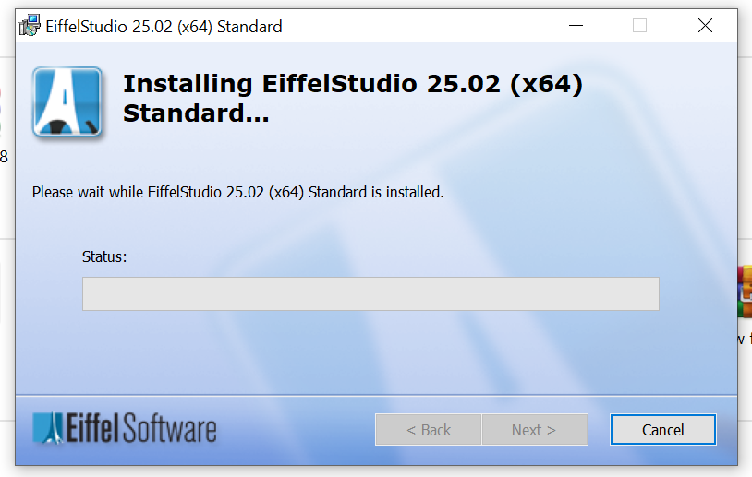

**7. Finish Installation**

* Uncheck **[ ] Launch EiffelStudio when setup exits** (optional).
* Click **Finish** to exit the installer.

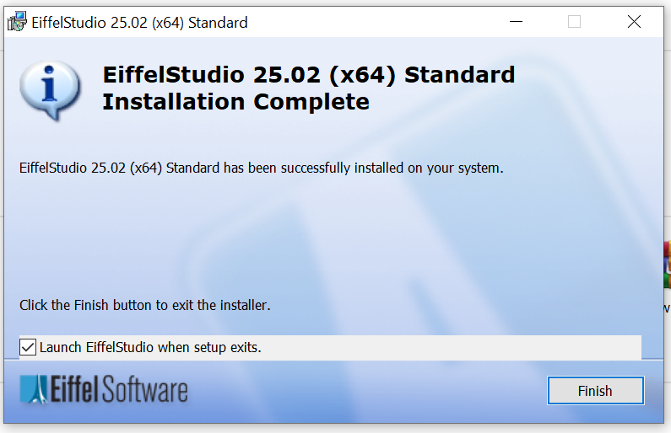

**Part 2: Bank Account with DBC in EiffelStudio**

**1. Launch Installer**



**2. Create New Project**

* **File** > **New** > **Project**
* Select Standard (Console Application)
* Name: **BankAccount_DBC**

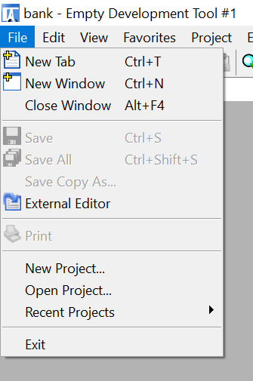

**3. Implement Bank Account Class**

Replace default code in **application.e** with:

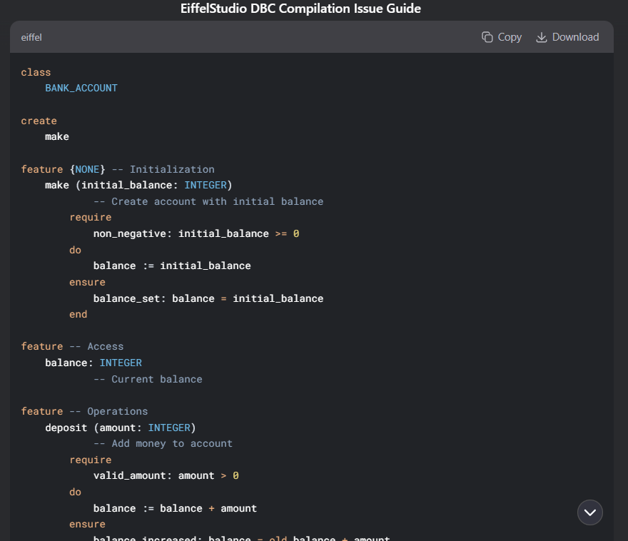

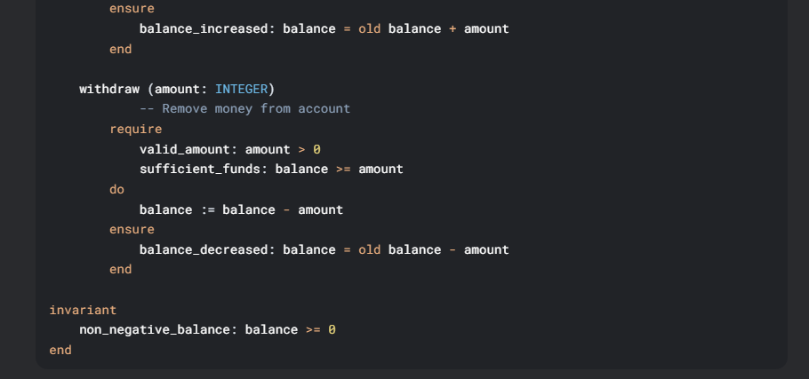

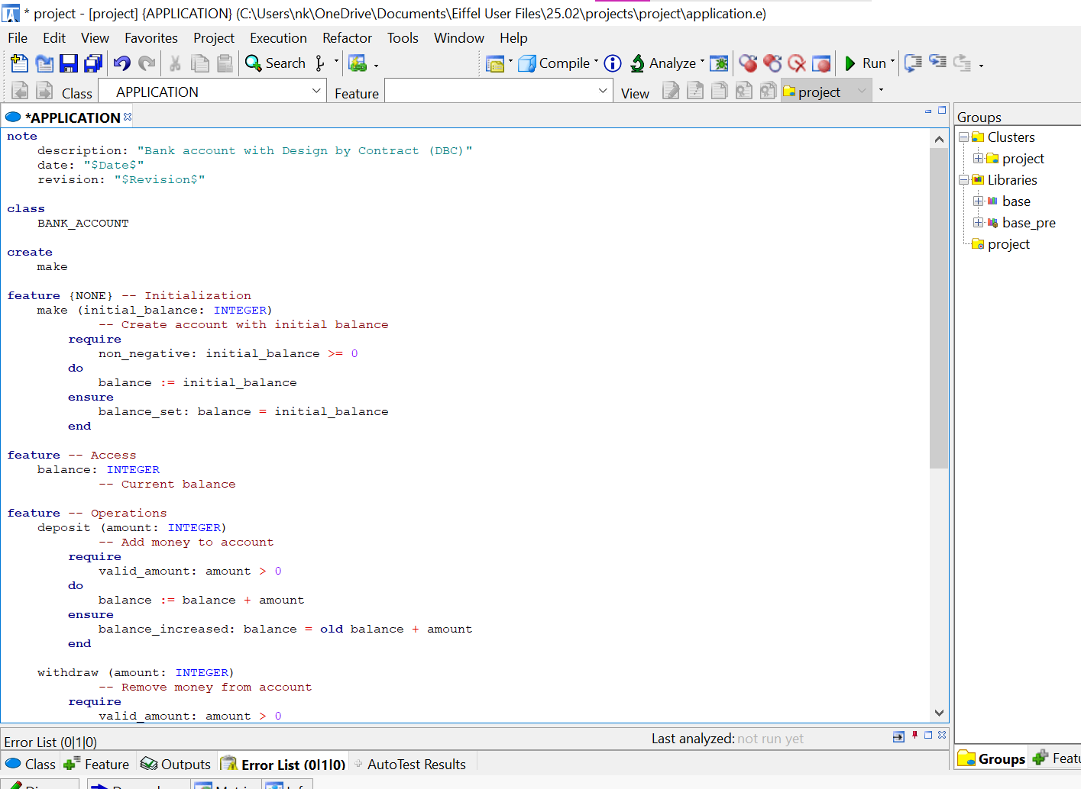

**Part 3: Compile & Run**

1. Compile: Press**F7** or click Compile
2. Run: Press**F9** or click Run

